Unitizing Calculations:

There are two methodologies available for the calculation of unitization on an estimate.

Original Logic:
The original base logic uses the Flute file to find the quantity per unit by flute, test and stacking pattern. This becomes the initial value for the quantity per unit on the estimate. The quantity bundle code (quantity per bundle) and pallet type are defaulted from the customer file. You can also have a different pallet type for each ship to.
On the initial estimate run it is feasible that the quantity per unit value is not divisible by the quantity per bundle and layers and stacks. For example a quantity per unit of 700 was found with a bundle count of 25, 5 stacks and 6 layers. If you push the “Unit Calc” button on the estimate ink/pack tab and then hit save the system will prompt “Make Quantities Equal?”. A “yes” response will re calc the quantity per unit to 750 (in this case 25 per bundle X 6 layers X 5 stacks).The “Override Unitizing” button allows you to change any of the unitizing values (bundle count, layers, stacks, stack pattern, quantity per unit).

For the initial estimate the system took the 700 from the Flute file (by flute, test and pallet type). It then got the pattern from the “Stack Size” matrix file based on the KDF footprint of the item. (The KDF formula resides in each style record). It then looks up the pattern code in the “Stack Pattern” table, in this case determining that there are 5 stacks. It then uses the board caliper from the raw material table (in this case .1600 for 200 C) and multiplies it by the 2 since the KDF length is ½ of the flat length (from the Style file). This result is a bundle height of 8 inches (25 X .1600 X 2). It then looks at the pallet size in the raw material file (in this case a P-50 is 40 x 48 x 50) and comes up with a number of layers by dividing 50 by the height of a bundle, 50 / 8 = 6 layers.

New Logic: (available approx 9/30/2006)
A new NK1 parameter called CEUnitQty will allow the user to either use the new logic (character value of AUTOCALC) or the existing old logic (character value of FluteMtx).

The key difference is that the new logic will by-pass the Flute Matrix for the quantity per unit, and will make the calculation without having to hit the “Unit Calc” button. The new logic will also improve on the accuracy of the quantity per unit by assuming that a pallet is 5 inches high. Thus, it will take the pallet code’s pallet depth and subtract 5 inches to make the unit quantity calculation. Such as: Layers=(Pallet Height - 5" of Wood) /(bundle count) x (caliper x style balecount). The layers will always be rounded down to the next whole value. The “unit calc” button will still be available, but it will now prompt “STACK UNDER PALLET HEIGHT ?” In other words, “Yes” will enforce the new logic (don’t exceed the unit height less the wood height), while no will allow you to alter the number of layers. This will pop up a window that shows the potential layer configurations to select from, such as:

Layers | Bndl Count | Stacks | Stack Height | Stk Height + 5” | Unit Count
6 | 25 | 5 | 48 | 53 | 750
5 | 25 | 5 | 40 | 45 | 625
4 | 25 | 5 | 32 | 37 | 500

This new logic will validate the shipto destinations with warehouse racks that have
limited height restrictions. The pallet + boxes will not exceed that limit. The “Unit
calc” button will prompt if a selection is made that exceeds the height limit.

Flute file for initial quantity per unit:

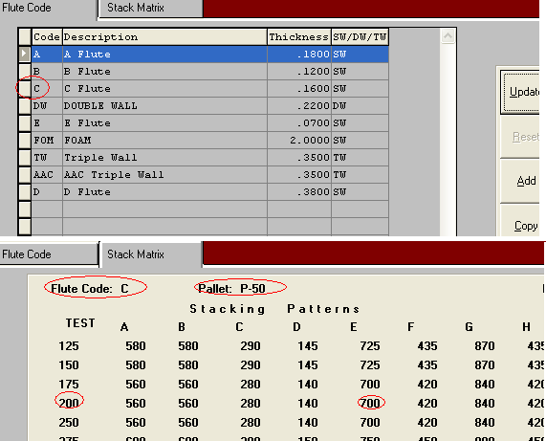

The bundle count and pallet type was found in the customer (or shipto) file.
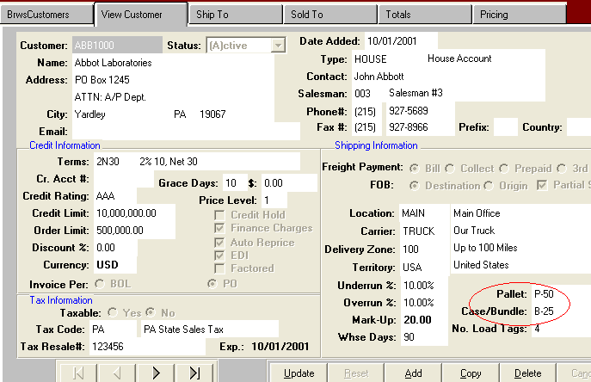
The Pallet Raw Material record stores the pallet height.
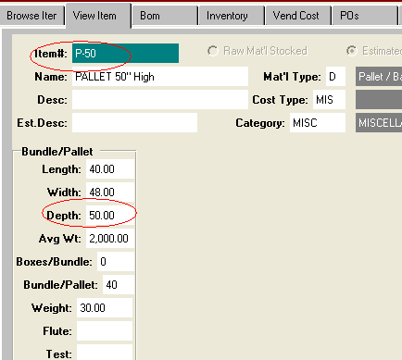

The Board Raw Material record stores the caliper.
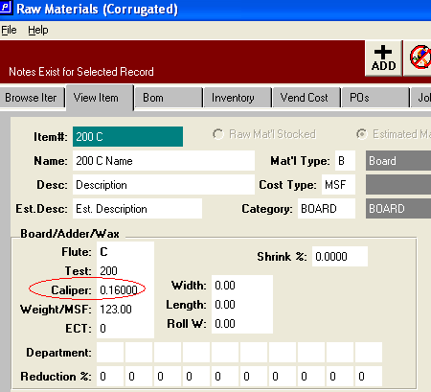

The style file has the KDF formula.
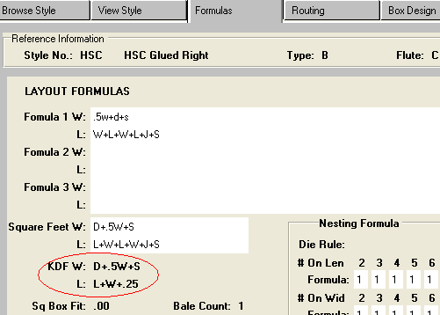

The Stack size matrix file contains the stacking styles for the KDF intersection values.
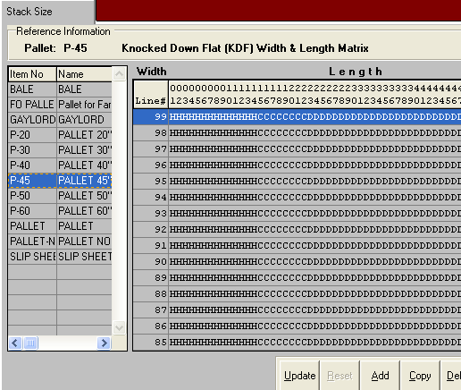

The Stack Pattern Table shows the stacks for each pattern as well as the number of straps. The strap formula is used to calculate the strap cost (the LWD are the pallet LWD from the Pallet raw material file.)
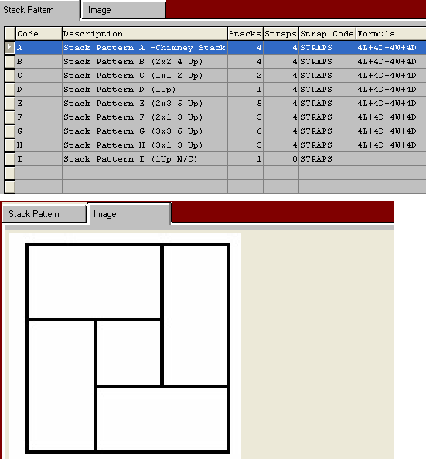

The estimate “Ink/Pack” tab shows the resulting values. In the Original Logic you should hit “Unit Calc” to assure a unit size that is divisible by the bundle, stack and layers.

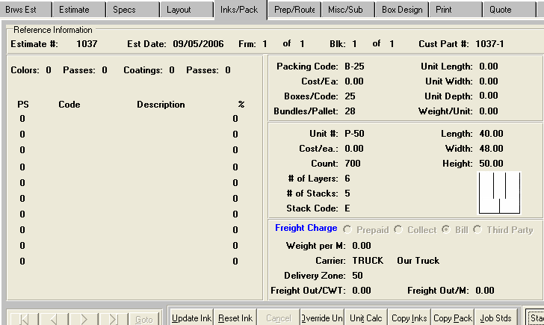

The Unit Calc button and the Override button have new logic to determine the stack height of the pallet. If you answer NO to stack under the pallet height, the system will provide various stack options. If you answer YES, then the system will automatically calculate the unit calculation under the pallet height.

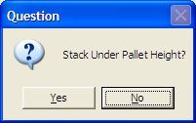

Answer no if you want to stack higher than a pallet, the system will display a menu that shows the height with and without a pallet. Simply double click the total number of layers high that you want to ship and the system will transfer to the screen. The Red lines indicate that the height is above the pallet height of 60 inches. The Green line indicates the maximum height under the 60" high pallet. The Yellow lines indicate that stacking option well below the pallet height.

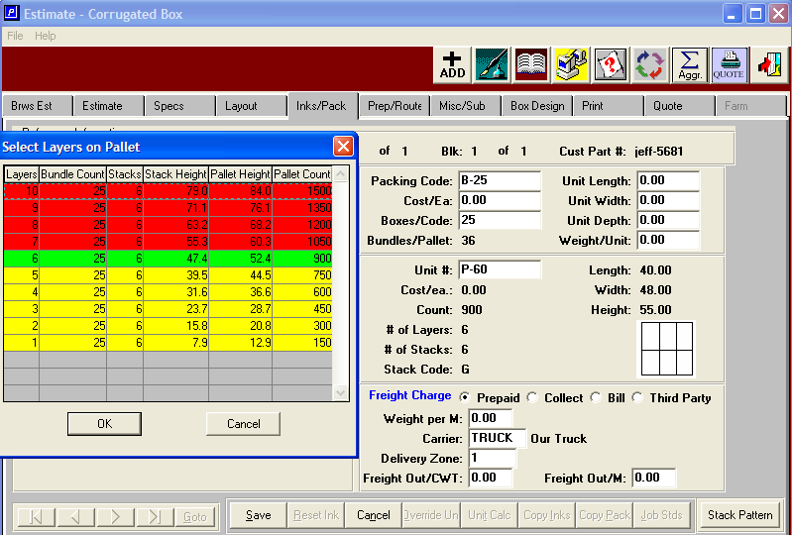

New N-K-1 CECUNIT parameters sets this logic in automatic mode.
Please note, this will level out all pallets so that top layer has the same amount of bundle stacks.

N-K-1 CECUnit Character Value = FluteMtx will import count from flute matrix.
N-K-1 CECUnit Character Value = AUTOCALC will use logic similar to N-Y-5.
Layers=(Pallet Height-5" of Wood /(bundle count x (caliper x 2/style balecount)
Unit Count = 7 layers x 25 per bundle x 6 stacks per layer = 1050
KDF Thickness is caliper x style balecount or .156 x 2/1
See Estimate 5655 for 8x8x8 box would calculate as
(60" - 5") / (25 x .156 x 2 ) = 7.05 layers rounded down to 7 layers.

Unitcalc Button will Prompt STACK UNDER PALLET HEIGHT ?
Yes will work like character value = Autocalc.
NO will display new popup allowing user to select number of layers.
Layers Bundle Count, Stacks, Stack Height, Pallet Height (+5") Pallet Count
8 25 6 62.4 67.4 " 1200
7 25 6 54.6 59.6 " 1050
6 25 6 46.8 51.8 " 900

Override now allows changing bundle counts, stacks and layers.
Upon SAVE button, if over pallet height, Prompt STACK IS HIGHER THEN PALLET HEIGHT, RECALC UNIT HEIGHT ? NO will just save. Yes will work like UnitCalc.

This new logic will validate shipto destinations with warehouse Racks with Limited Height restrictions that the pallet + Boxes MUST NOT exceed. The unit calc must prompt if this is EXCEEDING The Pallet DEPTH field. We may need to ROUND down the bundles to be under the Pallet height (Depth).

